Whales along the Shores of the Olympic Peninsula

This fall, NOAA Fisheries awarded Feiro Marine Life Center $25,226 in funding to support response to stranded marine mammals along the Strait of Juan de Fuca coast from Discovery Bay to the eastern edge of the Makah Indian Nation. This is the first time award from the John H. Prescott Marine Mammal Rescue Assistance Grant Program for the Juan de Fuca Stranding Network. Feiro had previously been responding to marine mammal stranding calls in the region on a volunteer basis. With this financial support, Feiro was able to hire a part-time stranding network coordinator, Helle Andersen, who coordinates Feiro’s citizen science programming. She is working with seasoned local marine mammal responders Ed Bowlby, Mary Sue Brancato and Rich Osborne, to recruit volunteers for this Clallam County-wide response team, as well as increasing efforts for education and public outreach.
“Feiro receives dozens of phone calls a year regarding seal pups on the shore, deceased cetaceans and other sightings. We will be able to provide more education to the public in areas they are most likely to encounter these animals, such as on Ediz Hook and near Cline Spit.” said Bob Campbell, Feiro’s facilities director, who led the effort to educate the public about the molting elephant seal at Hollywood beach in January 2015.
People interested in volunteering for the network response team or those interested in local whales should attend the Juan de Fuca network’s first public outreach event on December 3rd at the Red Lion Hotel. The panel discussion, “Whales in the Strait of Juan de Fuca,” will be moderated by Rich Osborne, Ph.D. of the University of Washington Olympic Natural Resource Center, and include speakers Jamie Valadez from the Lower Elwha Klallam Tribe, Shane Aggergaard from Island Adventures, the PA Whale Watch parent company, ________________ from Cascadia Research Collective and Helle Andersen of Feiro Marine Life Center. Speakers will cover whales in the Strait from historic to modern times, and what to do if you encounter a stranded marine mammal. An interest form will be available for those who want to be trained as a Juan de Fuca Stranding Network volunteer.
What: Whales in the Strait of Juan de Fuca
Date & Time: December 3, 2015 from 6:00-8:00pm
Admission: $7 (to offset costs)
Location: Red Lion Hotel, Port Angeles

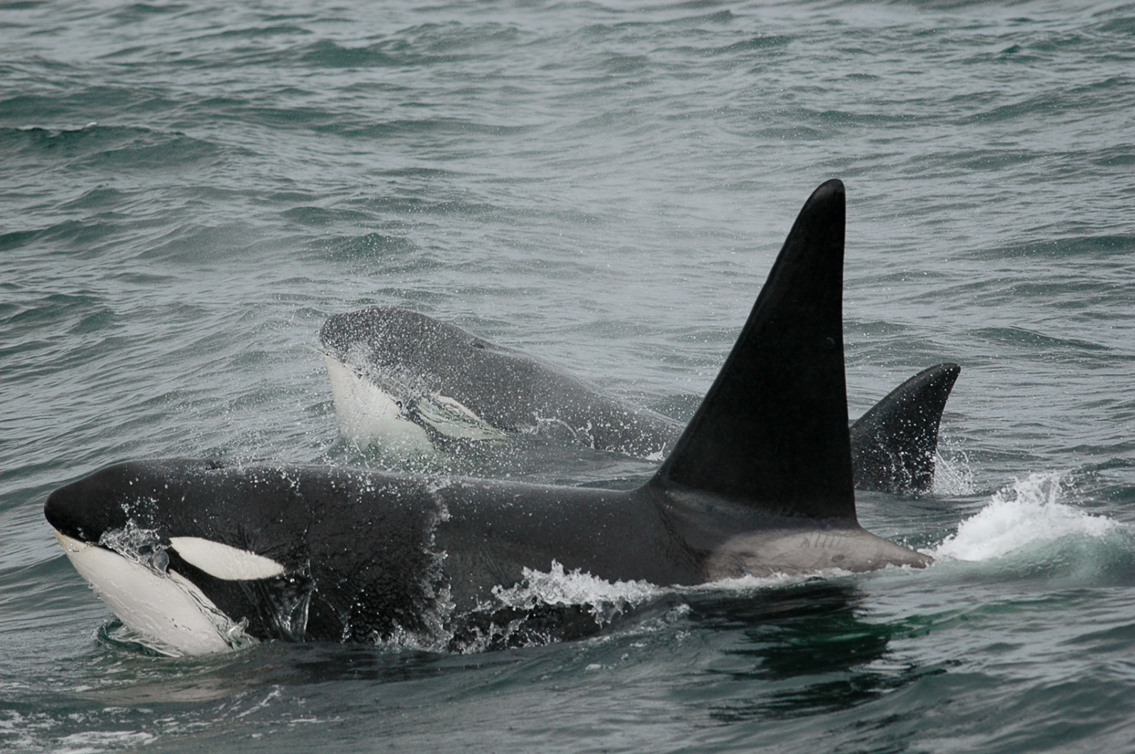
Photo credit: David Ellifrit, Used by permission from the NOAA (where is this file from?)

Also, this will have to be attached separately, not included in the word doc.

